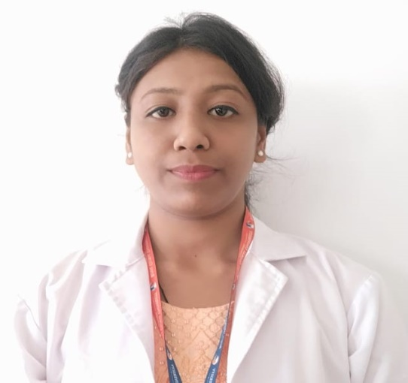

Dr. Himashree Medhi (PT), Assisstant Professor
Qualification:
Masters of Physiotherapy in Community Based Rehabilitation , Srimanta Sankaradeva University of Health Sciences(2019-2021)
Bachelors of physiotherapy (2014-2018) from College of Physiotherapy and Medical Sciences.
Work Experience :1 year and 1 month (in academic) , 3 years (clinical)
- Clinical experience in clinic (2018-2021)
- Science College , kokrajhar (Dec 2021- july 2022)
- The Assam Royal Global University (Aug 2022- till date)

- Training / Internship:
Hospital | Designation | Duration
Rabindranath Tagore International Institute of Cardiac Sciences | Intern | For the period of 6 month
PG Trainee in Swami Vivekanand National Institute of Rehabilitation Training and Research (SVNIRTAR) | Masters of Physical Therapy (Training) | For the period of 1 month, SEP 2019

Dissertation during MPT:
- “Prevalence of neck and shoulder pain among school teachers in kamrup districts’’(2019-2021)

Project during BPT:
- Project on different case studies(2017-2018)

